1. What is types statement in SAP ABAP programing?

Types is a statement which is used to define user-defined structure in SAP ABAP programming.

TYPES: BEGIN OF TY_TABLE,

MATNR TYPE MARA-MATNR,

MTART TYPE MARA-MTART,

MEINS TYPE MARA-MEINS,

END OF TY_TABLE.

1. What is DDIC?

It allows to create custom tables. There are other objects that can be created using DDIC viz. Data Elements, Domain, Lock Objects, Search Help, Structure, Table Type

1. How to add new fields to existing MARA or any other SAP table?

Append Structure, Include Structure

1. What is a Database Interface?

Database Interface is a component of the Application Server.

1. What tasks are done by the Database Interface?

The database interface provides the following services:

1. Converts Open SQL into Native SQL of the application.

2. Access to database tables.

3. Access to R/3 Repository objects (ABAP programs, screens and so on).

4. Access to catalog information (ABAP Dictionary).

5. Table buffer administration of the application server.

1. What role does Database Interface play for Open SQL?

The database interface Converts Open SQL into Native SQL of the application.

1. What is Open SQL?

Open SQL statements are a subset of Standard SQL. They allow you to access data irrespective of the database system that the R/3 installation is using. Open SQL consists of the Data Manipulation Language (DML) part of Standard SQL. It allows the user to read (SELECT) and change (INSERT, UPDATE, DELETE) data.

Open SQL thus provides a uniform syntax and semantics for all the database systems supported by SAP. ABAP programs that only use Open SQL statements will work in any R/3 system, regardless of the database system in use. Open SQL statements can only work with database tables that have been created in the ABAP dictionary

1. What is Native SQL?

Native SQL allows you to use database-specific SQL statements in an ABAP program.

To use Native SQL statement, you must precede it with the EXEC SQL statement, and follow it with the ENDEXEC statement. Native SQL statements are not checked and converted, but instead are sent directly to the database system.

An ABAP program containing database-specific SQL statements will not run under different database systems

1. What is a Data Element?

A data element in ABAP Dictionary defines an [elementary data type](javascript:call_link('abenelementary_data_type_glosry.htm')) or a [reference type](javascript:call_link('abenreference_type_glosry.htm')) and describes, the semantic meaning of an object.

The type attributes of a data element are defined either directly or using a domain.

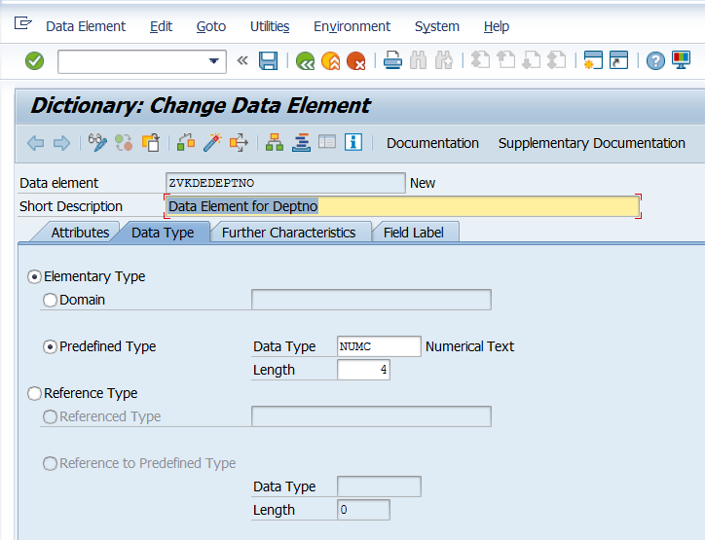

1. Can Data Element exist without a domain?

Yes. It can be based on Predefined Type as shown above.

1. Can Data Elements be searched?

Yes. SE11. Select Radio Button Data Type. Enter Object Name e.g. ZV*. Press F4.

In the screen that follows, Click on Search for Data Elements.

1. Where are field labels created in Data Dictionary?

Field Labels are created when a data Element is created.

1. Where is documentation in Data Dictionary?

Documentation is created when a data Element is created.

1. What is a Domain?

A [domain](javascript:call_link('abenddic_domains.htm')) describes the attributes of data elements, such as the actual data type or the value range. It can be used by any number of data elements.

A domain describes the technical settings of a table field. Also defines a value range, which sets the permissible data values for the fields, which refers to this domain. A single domain can be used as basis for any number of fields that are identical in structure.

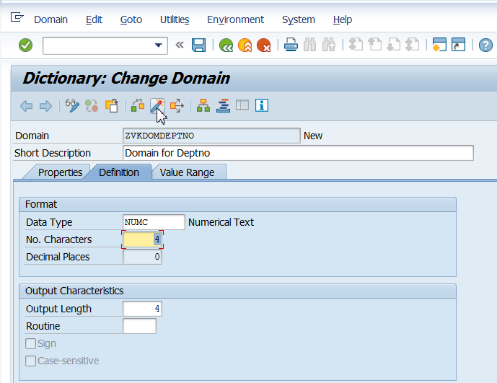

1. Can a domain exist without a Data Element?

No.

1. What is a check table?

It is a table which contains all valid entries of a field.

The check table defines the foreign keys and is part of the table definition. Check table is validation at field level. Check table is defined against a field in SE11 if you want the values in that field to be checked against a list of valid values. For e.g. if you are using the field matnr in a table you could define MARA as the check table.

1. What is value table?

It is a table which contains all valid entries of a domain. This domain can be reused in multiple tables. The check against the value table only takes effect when a foreign key* has been defined.

1. What is a database view?

Database views are implement an inner join, that is, only records of the primary table (selected via the join operation) for which the corresponding records of the secondary tables also exist are fetched. Inconsistencies between primary and secondary table could, therefore, lead to a reduced selection set. A matching SQL view is created on the database when the view is activated.

1. Identify the mandatory steps required to create a database view?

Following are the mandatory steps.

1. Select Tables
2. Establish Relationship Between Tables
3. Select fields
4. Selection Condition can be specified(Optional)

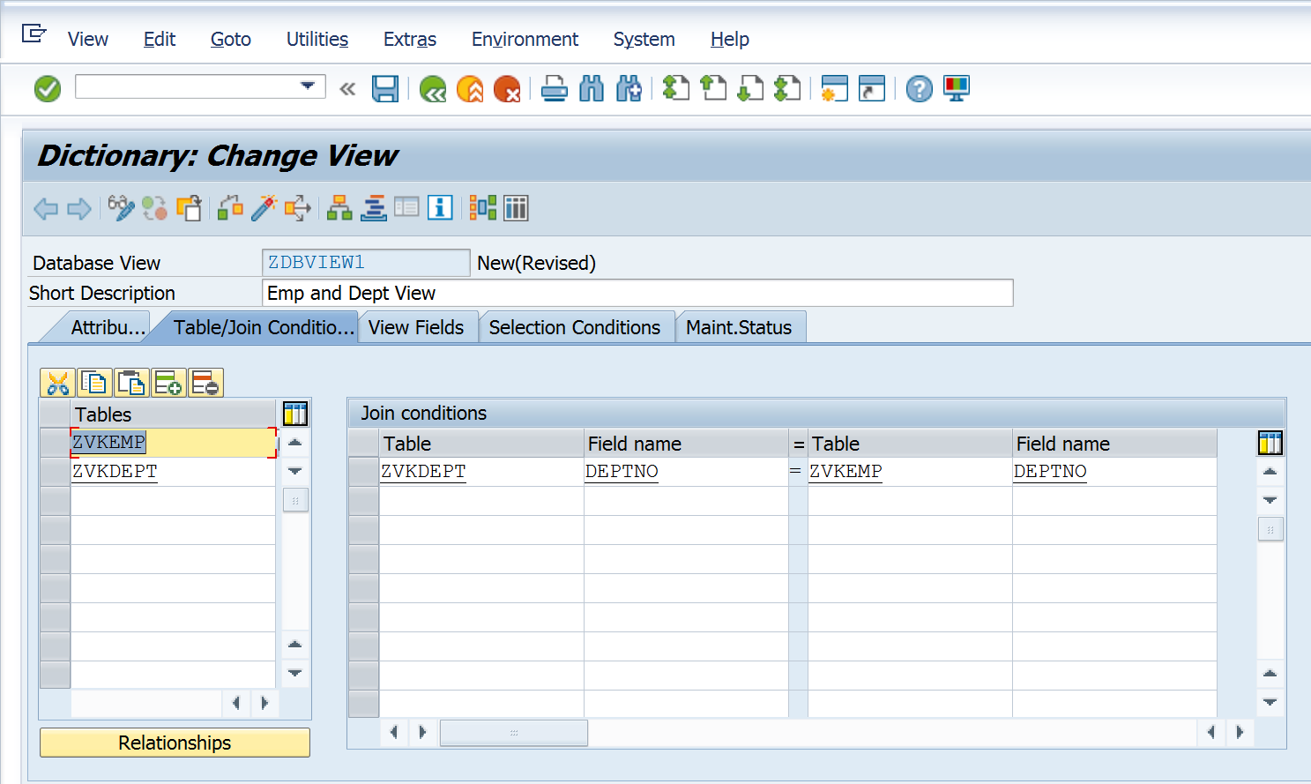

1. What is a projection view?

Projection view is a special view for hiding fields from a single basis table. An SQL view is not created on the database. No selection conditions can be specified for a projection view.

A projection view can be based on only one table.

|  |
| --- |
| 1. Can a search help be based on field based on pre-defined data types?   No. If you attach a search help to a field, such that the field is based only on the Predefined Type, you see the below message. In this case, an attempt is made to attach a search help to the field Ename. |
|  |
| 1. Can a search help be based on field based on data element? |
| Yes |
| 1. Can a search help be based on field based on domain?   Yes |
| 1. Can the selection method for a search help be a database table? |
| Yes |
| 1. Can the selection method for a search help be a view? Which type of view?   Yes. Database View (Inner Join), Help View (Outer Join).   1. What factors are considered in Data Dictionary Technical settings?   Data Class  Size Category  Buffering   1. What does the data class indicate?   Each data class corresponds to a physical area in which all the tables assigned to this data class are stored. If you choose the data class correctly, your table is automatically assigned to the correct area (table space).   1. What do you mean by buffers? How do buffers increase the system performance?   Buffering is an important in client/server environments, as it takes considerably longer to access a table with the network than it does to access a table that is buffered locally.  You use table buffering to improve performance when accessing the data records contained in the table. The table buffers reside locally on each application server in the system. The data of buffered tables can be accessed directly from the buffer of the application server. This avoids the time-consuming process of accessing the database.   1. What are the buffering types? 2. Single Record Buffering 3. Generic Areas Buffered 4. Fully Buffered 5. What is Full buffering? |
| You use full buffering to load all the records of the table into the buffer when one record of the table is read. With full buffering, either the entire table is in the buffer, or the table is not in the buffer at all.   1. When is full buffering used?   Full buffering is more suitable for smaller tables that are accessed frequently. This is because only one database access is necessary to load such a table with full buffering  Tables that are best suited to full buffering are rarely written and read frequently.  Full buffering is recommended in the following cases:   * Small tables such as customizing tables that are mainly read. * Larger Tables where large numbers of records are frequently read and rarely changed. But if these read accesses can be formulated with a selective WHERE condition using a database index, then it is recommended not to use buffering. * Tables for which read accesses to non-existent records are frequently submitted. Since all the table records reside in the buffer, the system can determine directly if a record exists or not in the buffer  1. What is Single Record Buffering?   You use single-record buffering to load into the buffer only the records that are actually read. Single-record buffering requires less storage space in the buffer than generic and full buffering.   1. When is single record buffering used?   Single record buffering is recommended for large tables from which single rows are often read using **SELECT SINGLE.**   1. What is a primary Index? When is it created?   The primary index contains the key fields of the table. The primary index is automatically created in the database when the table is activated.   1. Who decides whether to use primary index or not?   The database optimizer decides. The developer or DBA cannot decide whether to use a primary index or not.   1. What is a secondary index?   The secondary index contains of the non-key fields of the table.  Secondary Index is created for fields if they are used extensively in search. |

1. Who decides whether to use secondary index or not?

The database optimizer decides. The developer or DBA cannot decide whether to use a secondary index or not.

1. What are lock objects in SAP ABAP?

These types of objects are used for locking the access to database records in table. This mechanism is used to enforce data integrity that is two users cannot update the same data at the same time.

1. Is transparent table created in underlying Database?

Yes.

1. Is structure created in underlying Database?

No

1. What are the types of lock?

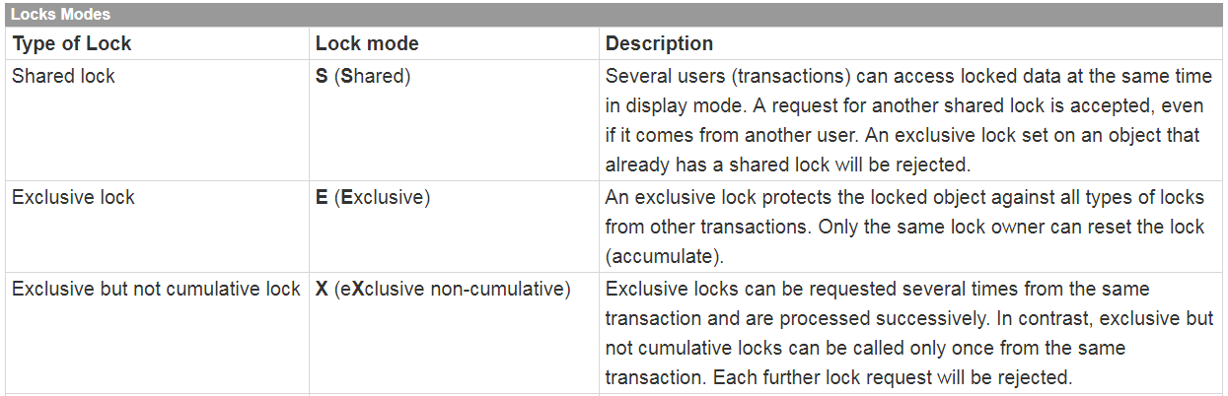

1. In Internal table, what is a hashed table?

**Hashed table** follows the hash algorithm. Here the declaration of key is must and the key must be unique. Hence, there will be no duplicate entry in the hashed table. We can access records only by the key. Data can be inserted here by INSERT statement. Hashed tables are used when the internal table contains huge volume of data. Using this type of table is good when you have large data-sets with a lot of reads, but comparatively few writes.

1. What happens when you insert such a record in a sorted table which violates the sort sequence? Syntax error? Runtime error?

Runtime Error.

1. What is a database utility used for?

Consider the following requirement.

You have created a ztable with 5 fields. This table is activated and being used.

Now, there is a need to delete some field or change the primary key. If you do this i.e. change the primary key and activate the table, an error will be shown during activation. This is because an attempt is being made to change the underlying table in the database. An attempt is made to alter a table. This alter is not permitted by Database.

You would see an error as below.

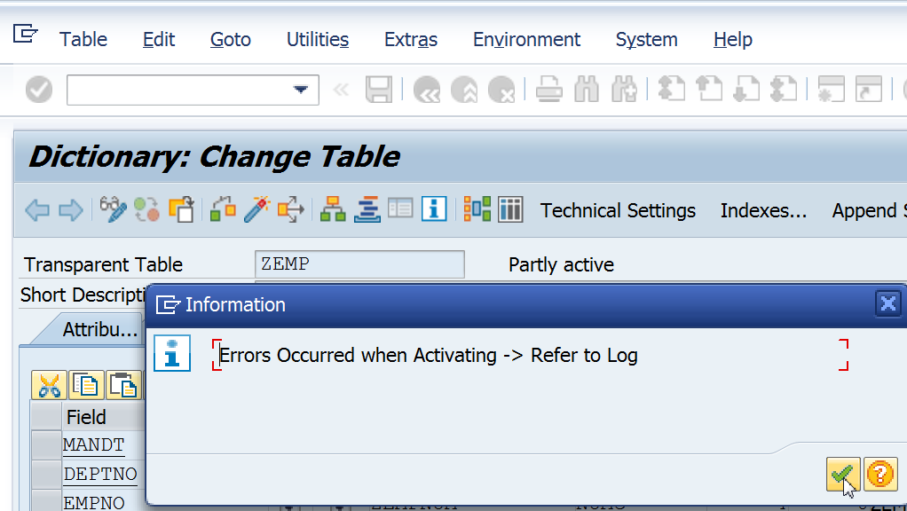

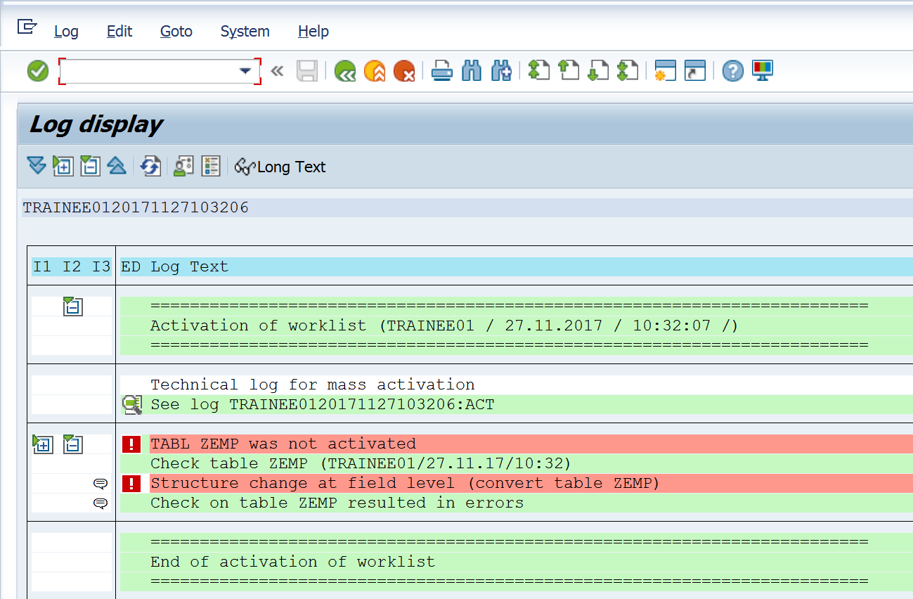

Hence, Database utility will have to be used.

For this we go to SE14 and there is one button 'Activate and Adjust Table'. On clicking this Button the changes of key fields are reflected successfully.

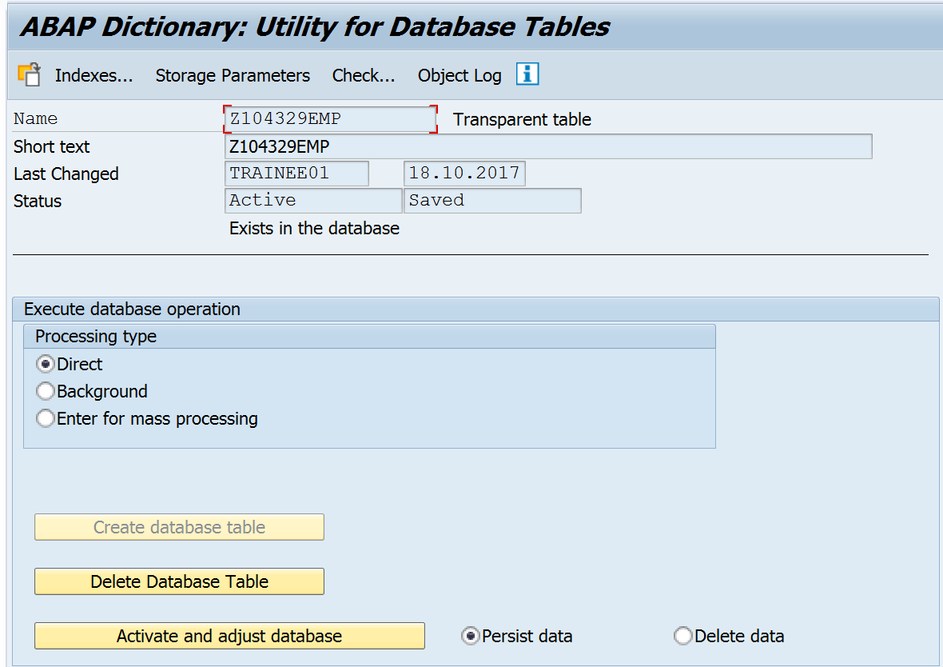

1. **Why we need to use Table Maintenance Generator?**

In production systems, the end-users generally won't be having access to SE11 or SE16 transaction code. So, if they need to maintain this table they need an alternate way to do so.

The benefit of Table Maintenance Generator is that the restriction can be put on each field column and gives end-users to change or modify multiple entries at the same time.

Table maintenance is required to maintain table Via Transaction code - SM30 and SM31.

1. **What are the different Maintenance type?**

There are two different Maintenance type - One Step and Two Step method.

**1. One Step Method -**In one step method there is only one overview screen. In single step over view screen number is compulsory but single screen is not required. In this case single screen number will get ignored. You can enter any screen number other than 1000, which is reserved for selection screen. In One Step Method, you will be able to see and maintain only through overview screen.   
**2. Two Step Method -**In two step method there is two screens. Over View Screen and Single Screen (Detail Screen). Here both the screen (Overview and Single) number is required to enter. In this the overview screen contains only the key fields and single screen contains all the fields.

1. What are the events in Classical Reporting?

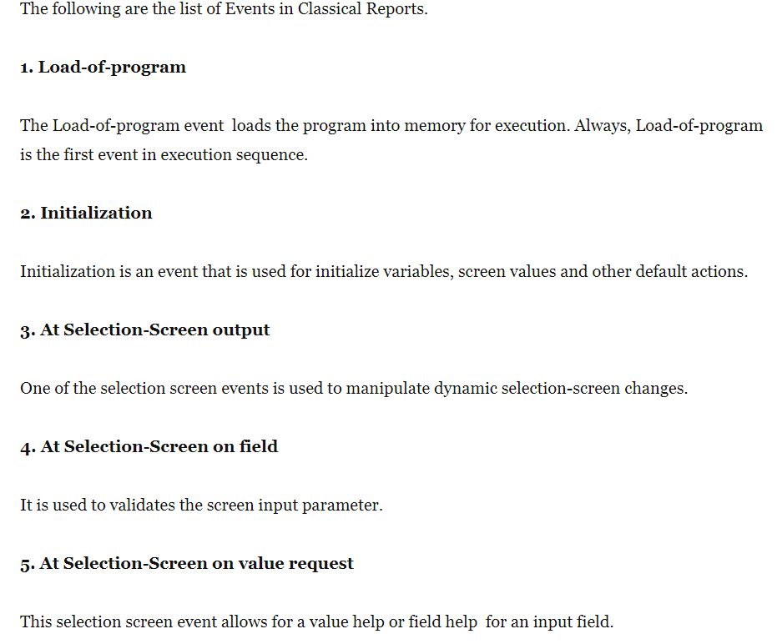

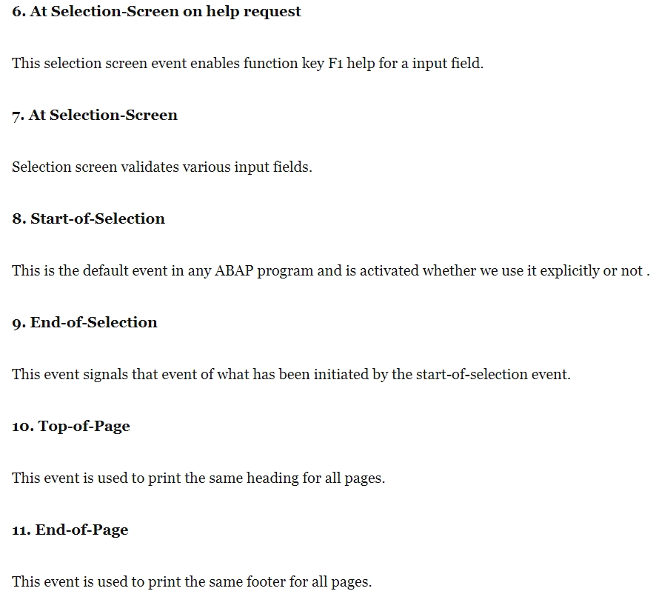

1. In which event do you validate the select-options?

At Selection-Screen

At Selection-Screen on Field

1. How to calculate subtotal in classical events?

These are calculated using following control break statements of Internal Tables.

* at first / endat
* at last / endat
* at new / endat
* at end of / endat
* sum
* on change of / endon

1. What are the events in Module Pool Programming?

PBO event – Process Before Output

This event is triggered before the screen is displayed. The processing of screen before the display of screen is done in this event. For example, filling in default values in the screen fields.

PAI event – Process After Input

This event is responsible for processing of screen after the user enters the data and clicks the pushbutton. The processing of screen can include displaying another screen, or just displaying list or quitting the transaction itself and many more things. Usually it is displaying another screen. These operations can be carried out in the PAI event. OKCODE plays an important role in this operation.

POV event

Process on value request is triggered when the user clicks F4 key. You can handle this event when the user presses F4 key by writing code for the same in module pool program. Normally when the user presses F4, list of possible values is displayed. The standard list produced by system is adequate for applications you develop yourself. However, you can also have the option of setting up your own documentation and lists of possible values that are more detailed.

POH event

Normally when the user places the cursor on the field and presses F1 function key, the system displays its own Help for that field. You can add your own functionality to the Help button by writing code for the same in the POH event.

1. What is the event used to navigate from basic list to secondary list?

At line-selection

At user-command

At PF Status

1. What does screen-active = 0 imply?

The screen element will not be shown while run-time

1. What is a structure?

Structures are data objects (comprised of components of any data type) that are saved in sequence in the memory. The data type of a structure is a structured type or a structure defined in the ABAP Dictionary.

1. Does a structure store data?

No

1. What is a view?

A view in ABAP Dictionary is a grouping of columns in one or more database tables in accordance with an application-specific view

1. Does a view store data?

No

1. What is subroutine? Why do you use it?

Subroutines were originally designed for the internal modularization of a program

1. What is a function module?

SAP functional modules are specialized components within the SAP system that focus on specific business processes or functional areas

1. What is the difference between subroutine and function module?

FMs are mainly used when a routine is to be performed by many programs. Subroutines (forms) are generally only executed within one program. You can perform routines from other programs, but it's not often done. Both forms and FMs are reusable modularization units.

1. Can a function module exist without a function group? NO
2. What Tcode is used to create Function Module? SE37
3. Is it necessary to create a Function group before creating a function module? Yes
4. Is it necessary to create a Function group before creating a subroutine? No
5. What is the meaning of Pass By Value in a subroutine?

pass by value means you are making a copy in memory of the actual parameter's value that is passed in, a copy of the contents of the actual parameter

1. What is the meaning of Pass By reference in a subroutine?

Pass by reference does not create a local data object for the actual parameter. Instead, a reference to the actual parameter is passed to the procedure when it is called and the procedure works with the actual parameter itself

1. How do you pass a parameter by Value in a subroutine?

PERFORM my_subroutine USING lv_value.

WRITE: / 'Value after subroutine:', lv_value.

FORM my_subroutine USING p_value TYPE i.

p_value = p_value + 5.

WRITE: / 'Value inside subroutine:', p_value.

ENDFORM.

1. How do you pass a parameter by Reference in a subroutine?

PERFORM my_subroutine CHANGING lv_value.

WRITE: / 'Value after subroutine:', lv_value.

FORM my_subroutine CHANGING p_value TYPE i.

p_value = p_value + 5.

WRITE: / 'Value inside subroutine:', p_value.

ENDFORM.

1. What is the addition ‘using’ used for in a subroutine?

The USING addition is used in a subroutine to define parameters that are passed by value. This means that a copy of the actual parameter is passed to the subroutine, and any changes made to the parameter within the subroutine do not affect the original parameter outside the subroutine.

1. What is the addition ‘Changing’ used for in a subroutine?

The CHANGING addition is used in a subroutine to define parameters that are passed by reference. This means that any changes made to the parameter within the subroutine will directly affect the original parameter outside the subroutine.

1. You have defined a variable in a subroutine. Is this variable available to other subroutines defined in the same program? No
2. You have defined a variable in a Function Module. It this variable available to other

subroutines/ Function Module defined in the same Function Group? No

1. What is At Selection screen output used for?

The AT SELECTION-SCREEN OUTPUT event in ABAP is used to manipulate the selection screen before it is displayed to the user. This event allows you to dynamically modify the selection screen, such as:

* **Hiding or displaying fields**: You can make certain fields visible or invisible based on specific conditions.
* **Setting default values**: You can set default values for fields before the screen is shown.
* **Modifying field properties**: You can change properties like enabling or disabling fields.
* **Adding custom logic**: You can add custom logic to be executed before the selection screen is displayed.

1. Difference between Data Element and Domain.

Data Element: Focuses on the semantic meaning and additional properties of a field.

Domain: Focuses on the technical attributes and ensures consistency.

1. What is the structure of Select options?

TYPES: BEGIN OF linetype,

sign(1) TYPE c,

option(2) TYPE c,

low {TYPE type} | {LIKE dobj}

high {TYPE type} | {LIKE dobj}

END OF linetype.

1. What is the difference between view and table?

Tables: Store actual data and are used for CRUD (Create, Read, Update, Delete) operations.

Views: Do not store data physically but provide a way to retrieve and present data from one or more tables.

1. Difference between Update and Modify statement?

UPDATE: Specifically updates existing records based on a condition.

MODIFY: Can both update existing records and insert new ones if the record does not exist.

1. Difference between If and Check statement?

IF Statement: Used for conditional execution of code blocks with multiple branches.

CHECK Statement: Used to exit the current processing block if a condition is not met, effectively acting as a filter.

1. What is a GUI status?

In ABAP, a GUI status is a collection of interface elements that define the layout and functionality of the user interface for an SAP screen. It includes elements like menus, toolbars, and function keys. The GUI status is created and managed using the Menu Painter tool in the ABAP Workbench.

Components of a GUI Status

Menu Bar: The horizontal bar at the top of the screen that contains menus.

Application Toolbar: The toolbar below the menu bar that contains buttons for frequently used functions.

Function Keys: Keyboard shortcuts that trigger specific actions.

Title Bar: The title of the screen.

1. What is the sequence of events in Classical report?

INITIALIZATION: This event is triggered before the selection screen is displayed. It is used to initialize variables and set default values for selection screen parameters.

AT SELECTION-SCREEN OUTPUT: This event is triggered before the selection screen is displayed. It is used to modify the selection screen dynamically.

AT SELECTION-SCREEN: This event is triggered after the user has entered data on the selection screen and pressed the execute button. It is used to validate the user input.

START-OF-SELECTION: This event is triggered after the selection screen processing is complete. It is the main processing block where the majority of the report logic is implemented.

END-OF-SELECTION: This event is triggered after the START-OF-SELECTION event. It is typically used for final processing and output of the report.

TOP-OF-PAGE: This event is triggered at the beginning of a new page during list processing. It is used to define the page header.

END-OF-PAGE: This event is triggered at the end of a page during list processing. It is used to define the page footer.

TOP-OF-PAGE DURING LINE-SELECTION: This event is triggered at the beginning of a new page during secondary list processing (when the user drills down into the report).

AT LINE-SELECTION: This event is triggered when the user double-clicks on a line in the basic list. It is used to create secondary lists.

AT USER-COMMAND: This event is triggered when the user interacts with the report using function keys or buttons.

1. What event is used for Validation?

The AT SELECTION-SCREEN event is commonly used for validation of user input on the selection screen. This event is triggered after the user has entered data and pressed the execute button, but before the main processing of the report begins. It allows you to check the validity of the input and provide feedback to the user if necessary.

1. What is the use of event At Selection screen?

This event is triggered after the user has entered data on the selection screen and pressed the execute button. It is used to validate the user input.

1. What is the use of event At Selection screen output?

This event is triggered before the selection screen is displayed. It is used to modify the selection screen dynamically.

1. In the classical events which event is equivalent to PBO and PAI of MPP?

The TOP-OF-PAGE event sets up the page header, similar to PBO.

The AT LINE-SELECTION event handles user interactions, similar to PAI.

1. When is the TOP-OF-PAGE event triggered?

This event is triggered at the beginning of a new page during secondary list processing (when the user drills down into the report).

1. What are interactive reporting events?

In ABAP, interactive reporting allows users to interact with the report output, typically by clicking on lines to drill down into more detailed information. Interactive reporting events are triggered by user actions and enable the creation of secondary lists based on the user's selections. Here are the main interactive reporting events:

AT LINE-SELECTION

Purpose: Triggered when the user double-clicks on a line in the basic list.

Usage: Used to create and display a secondary list with more detailed information about the selected line.

Example:

AT LINE-SELECTION.

WRITE: / 'You selected line:', sy-lisel.

AT USER-COMMAND

Purpose: Triggered when the user interacts with the report using function keys or buttons.

Usage: Used to handle custom user commands and perform specific actions based on the command.

Example:

AT USER-COMMAND.

CASE sy-ucomm.

WHEN 'BACK'.

LEAVE TO SCREEN 0.

WHEN 'EXIT'.

LEAVE PROGRAM.

WHEN OTHERS.

" Handle other commands

ENDCASE.

TOP-OF-PAGE DURING LINE-SELECTION

Purpose: Triggered at the beginning of a new page during secondary list processing.

Usage: Used to define the page header for secondary lists.

Example:

TOP-OF-PAGE DURING LINE-SELECTION.

WRITE: / 'Secondary List Header'.

Example of Interactive Report

Here's a simple example of an interactive report that uses these events:

REPORT zinteractive_example.

DATA: itab TYPE TABLE OF spfli,

wa TYPE spfli.

START-OF-SELECTION.

SELECT * FROM spfli INTO TABLE itab.

LOOP AT itab INTO wa.

WRITE: / wa-carrid, wa-connid, wa-cityfrom, wa-cityto.

ENDLOOP.

AT LINE-SELECTION.

GET CURSOR LINE sy-lilli.

READ TABLE itab INDEX sy-lilli INTO wa.

IF sy-subrc = 0.

WRITE: / 'Detailed Information:',

/ 'Carrier ID:', wa-carrid,

/ 'Connection ID:', wa-connid,

/ 'City From:', wa-cityfrom,

/ 'City To:', wa-cityto.

ENDIF.

TOP-OF-PAGE DURING LINE-SELECTION.

WRITE: / 'Detailed Information Header'.

1. How do we achieve interactive reporting using the FM REUSE_ALV_GRID_DISPLAY?

Like in classical event it is At Line Selection

Internal Table and Field Catalog: Define and populate these to hold your data and describe the fields.

Event Table: Set up the event table to handle user actions.

Event Handler: Create a form to handle the double-click event.

Display ALV Grid: Use REUSE_ALV_GRID_DISPLAY to display the grid and link the event handler.

This setup allows you to achieve interactive reporting with ALV, similar to handling AT LINE-SELECTION in classical reports.

1. What is difference between value request and help request?

Value Request (F4 Help): Provides a list of possible values for selection.

Help Request (F1 Help): Provides detailed information or documentation about the field.

POV Event

Process on value request is triggered when the user clicks F4 key. You can handle this event when the user presses F4 key by writing code for the same in module pool program. Normally when the user presses F4, list of possible values is displayed. The standard list produced by system is adequate for applications you develop yourself. However, you can also have the option of setting up your own documentation and lists of possible values that are more detailed.

POH event

Normally when the user places the cursor on the field and presses F1 function key, the system displays its own Help for that field. You can add your own functionality to the Help button by writing code for the same in the POH event.

1. What is the use of TMG?

In production systems, the end-users generally won't be having access to SE11 or SE16 transaction code. So, if they need to maintain this table they need an alternate way to do so.

The benefit of Table Maintenance Generator is that the restriction can be put on each field column and gives end-users to change or modify multiple entries at the same time.

Table maintenance is required to maintain table Via Transaction code - SM30 and SM31.

1. What is SM30? What will you see in SM30?

We see maintenance view for that table.

**SM30** is a transaction code in SAP used to maintain table entries. It provides a user-friendly interface to view, edit, and manage data in database tables through maintenance views.

**What You See in SM30**

When you execute transaction **SM30**, you typically see the following:

1. **Table/View Name**: You enter the name of the table or view you want to maintain.
2. **Maintenance View**: If a maintenance view is defined for the table, you will see a screen that allows you to:
   * **Display Entries**: View existing records in the table.
   * **Edit Entries**: Modify existing records.
   * **Add New Entries**: Insert new records into the table.
   * **Delete Entries**: Remove records from the table.
3. **Buttons and Options**: Various buttons and options to navigate, save changes, and perform other actions.
4. I have a requirement to validate on screen. What event will be used for?
5. Name few statements used to work on Data in Internal table. i.e Append like Append what are the other statements?

In ABAP, there are several statements used to work with data in internal tables. Here are a few commonly used ones:

APPEND

Purpose: Adds a new row to the end of an internal table.

Syntax:

APPEND wa TO itab.

INSERT

Purpose: Inserts a new row at a specified position in an internal table.

Syntax:

INSERT wa INTO itab INDEX idx.

MODIFY

Purpose: Modifies an existing row in an internal table.

Syntax:

MODIFY itab FROM wa INDEX idx.

DELETE

Purpose: Deletes one or more rows from an internal table.

Syntax:

DELETE itab WHERE condition.

READ TABLE

Purpose: Reads a row from an internal table into a work area.

Syntax:

READ TABLE itab INTO wa WITH KEY key.

LOOP AT

Purpose: Iterates over all rows in an internal table.

Syntax:

LOOP AT itab INTO wa.

" Processing logic

ENDLOOP.

CLEAR

Purpose: Clears the contents of a work area or an internal table.

Syntax:

CLEAR wa.

CLEAR itab.

SORT

Purpose: Sorts the rows of an internal table.

Syntax:

SORT itab BY field1 field2.

REFRESH

Purpose: Clears all rows from an internal table.

Syntax:

REFRESH itab.

FREE

Purpose: Releases the memory allocated to an internal table.

Syntax:

FREE itab.

1. What is the difference between inner join and left outer join?
2. What is the reason for using CDS views?

Core Data Services (CDS) views are a powerful feature in SAP that provide several advantages for data modeling and access. Here are some key reasons for using CDS views:

1. Enhanced Data Modeling

Semantic Layer: CDS views provide a semantic layer that allows you to define and consume data models directly in the ABAP layer.

Complex Joins and Associations: They support complex joins and associations, making it easier to model relationships between different data entities.

2. Performance Optimization

Push-Down Capabilities: CDS views leverage the database's capabilities to perform operations, reducing the load on the application server and improving performance.

Efficient Data Retrieval: By defining views that only retrieve the necessary data, CDS views help in optimizing data retrieval and reducing data transfer volumes.

3. Reusability and Maintainability

Reusable Components: CDS views can be reused across different applications and reports, promoting consistency and reducing redundancy.

Modular Design: They support a modular design approach, making it easier to maintain and update data models.

4. Integration with SAP HANA

Native HANA Features: CDS views can take advantage of native SAP HANA features such as full-text search, spatial data processing, and advanced analytics.

Optimized for HANA: They are optimized for SAP HANA, ensuring that you get the best performance and capabilities from your HANA database.

5. Advanced Features

Annotations: CDS views support annotations that provide metadata and additional information, enhancing the functionality and integration with other SAP tools.

Access Control: They allow for fine-grained access control using CDS roles and authorizations, ensuring data security and compliance.

Example

Here’s a simple example of a CDS view definition:

@AbapCatalog.sqlViewName: 'ZCUSTOMER_VIEW'

@AccessControl.authorizationCheck: #CHECK

@EndUserText.label: 'Customer Data'

define view ZCustomerView as select from zcustomers

{

key customer_id,

name,

city,

country

}

In this example:

The CDS view ZCustomerView is defined to select data from the zcustomers table.

Annotations are used to provide metadata and control access.

1. What are the performance tuning techniques that you would use in your code to optimize?
2. What is the difference between if and case?

IF Statement: Best for evaluating multiple unrelated conditions. It provides flexibility with ELSEIF and ELSE branches.

CASE Statement: Best for evaluating a single variable against multiple possible values. It is more readable and efficient for this purpose.

1. What is index in a database table?

An index in a database table is a data structure that improves the speed of data retrieval operations on a table at the cost of additional storage space and maintenance overhead. Indexes are used to quickly locate and access the data without having to search every row in a table each time a database table is accessed.

Key Points about Indexes:

Purpose: The primary purpose of an index is to enhance the performance of data retrieval operations. It allows the database to find rows more quickly and efficiently.

Types: There are several types of indexes, including:

Primary Index: Automatically created when a primary key is defined. It ensures the uniqueness of the primary key values.

Secondary Index: Created explicitly by the user to improve the performance of queries that are not covered by the primary index.

Unique Index: Ensures that the indexed columns do not contain duplicate values.

Non-Unique Index: Allows duplicate values in the indexed columns.

Structure: Indexes are typically implemented using data structures like B-trees or hash tables, which allow for efficient searching, insertion, and deletion operations.

Usage: Indexes are used in SQL queries to speed up the retrieval of rows. For example, when you use a WHERE clause to filter rows, the database can use an index to quickly find the matching rows.

Example

Consider a table ZCUSTOMERS with fields CustomerID, Name, and City. If you frequently query this table based on the City field, you can create an index on the City field to improve query performance:

CREATE INDEX idx_city ON ZCUSTOMERS (City);

Benefits and Trade-offs

Benefits: Faster query performance, especially for large tables.

Trade-offs: Increased storage space and maintenance overhead, as indexes need to be updated whenever the data in the table changes.